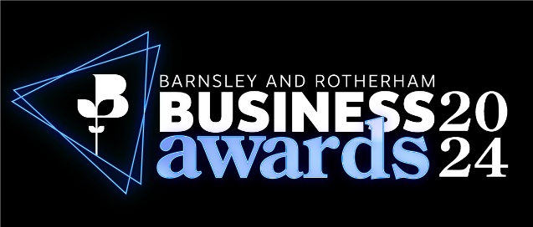
Entry Form 2024
Charity of the Year

The winner of this award will receive a cash prize donation for their chosen project, initiative or need and become the Chamber’s Charity of the Year.

Prizes are not to be used for overheads or staffing costs and will only be awarded to eligible charities who are registered with the Charity Commission. We will not accept applications for activities carried out by subsidiaries and ventures partially owned by charities.

The Judges will be looking for the following:
- The project, initiative or need that would benefit from the funding.
- How do you feel the winning this award will benefit your organisation.
- How the local community will benefit from the award and prize fund.

Eligibility
- Only open to Charity members of the Chamber.
- Must be registered with the Charity Commission.

Please email your completed entry form to awards@brchamber.co.uk
The closing date for applications is 5pm, Monday, 9th September 2024

Contact Information

Contact Name: Email Address:

Position: Telephone:

Company Name: Product/Service:

Website: Number of Employees:

Annual Income: Charity Reg No.

Membership No.
Company Address:

In no more than 30 words, please give a description of your charity.
(This will be used in publicity material should your bid be successful)

In no more than 100 words, please give a summary of why you feel your charity should win this award.
(Should you be successful, this information will be used at the Awards Ceremony)

Application
Please provide a supporting statement for the following questions comprising of a maximum of 500 words per question.
(Ensure you meet the entry criteria in this section – this can be found at the start of this document)
What would you do with the prize money? (For example a project, initiative or need such as equipment)

What would winning mean to you and what benefit would the prize money have on your organisation?

What impact would winning have on the local community?

Word Count:

The Rules

- The closing date for entries is 5 pm Friday, 12th September 2025.
- The Awards are open to all businesses with an ‘S’ postcode and all members of Barnsley & Rotherham Chamber of Commerce regardless of location and are free to enter.
- Entries must be electronic and in one single document in either Microsoft Word or PDF format, and in English.
- Entrants can find the criteria online at www.brawards.co.uk and on the respective category page.
- Entrants must be authorised to enter their organisation/a person into the awards programme.
- Entrants should keep to the word count. Text boxes can be expanded if necessary.
- The maximum file size for any entry is 5MB.
- Supporting information should be included in the entry form, these can be tables, pictures, graphs (a maximum of 5 in total). Please be aware that website links used within your entry will not be activated by the judges.
- All entries will be acknowledged when received, within a two-day working period. All entries are treated as confidential and entry forms will become the property of Barnsley & Rotherham Chamber of Commerce. These will be shared with the judges of the awards. Entries will not be returned.
- The judges’ decision is final, and no correspondence will be entered into.
- Judges reserve the right to audit any information supplied.
- Barnsley & Rotherham Chamber of Commerce reserves the right to withdraw an award from any applicant supplying false information within their entry.
- No employee of Barnsley & Rotherham Chamber of Commerce shall be entitled to enter.
- Award winners will be announced at the Barnsley and Rotherham Business Awards ceremony on Friday, 8th November 2024.
- The shortlisting of an application does not include complimentary places at the Barnsley and Rotherham Business Awards. By entering and therefore potentially being shortlisted for any category it is required that your organisation attend the ceremony. Costs to attend the ceremony can be found at www.brawards.co.uk
- By registering and completing an entry form for the awards you are agreeing to these terms and conditions.

Judging

- Each category will be judged by an independent panel and the award sponsor.
- All entries received by the deadline will be judged and a final shortlist will be drawn up.
- It is anticipated that up to five finalists will be shortlisted in each category.
- All shortlisted will be notified prior to the ceremony by Barnsley & Rotherham Chamber of Commerce and further information may be requested for the ceremony.
- Details of the ceremony can be found online at www.brawards.co.uk

