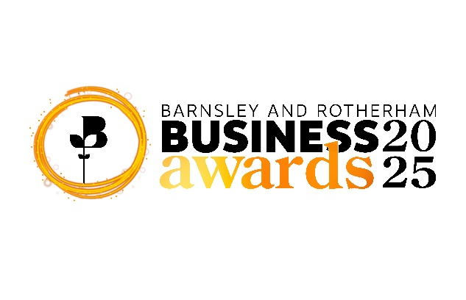
Entry Form 2025
Sustainability Award
The application rules can be found at the end of this form. Any entries not adhering to the rules may be disqualified, however you will be notified by Barnsley & Rotherham Chamber of Commerce staff.
Criteria for this award
The judges will be looking for evidence of the following:
- What specific actions or initiatives has your organisation undertaken to promote sustainability and achieve a positive environmental impact?
- What sustainability initiatives has your organisation implemented to reduce its carbon footprint?
- What strategies or programs does your organisation have in place to engage employees in sustainability practices?
- How does your organisation collaborate with suppliers to ensure environmentally responsible practices throughout the supply chain?
Please email your completed entry form to awards@brchamber.co.uk
The closing date for applications is 4pm, Friday, 12th September 2025

Award Category you wish to be nominated for:
Sustainability Award

Contact Information

Contact Name: Email Address:

Position: Telephone:

Company Name: Product/Service:

Website: Number of Employees:

Established:
Company Address:

In no more than 30 words, please give a description of your business.
(This will be used in publicity material should your bid be successful)

In no more than 100 words, please give a summary of why you feel your business/employee should win this award.
(Should you be successful, this information will be used at the Awards Ceremony)

In no more than 1,000 words, please give full details in support of your application, in particular to the criteria the judges have provided.
(Ensure you meet the entry criteria in this section – this can be found at the start of this document)

Word Count:

The Rules

- The closing date for entries is 4pm, Friday, 12th September 2025
- The Awards are open to all businesses with an ‘S’ postcode and all members of Barnsley & Rotherham Chamber of Commerce regardless of location and are free to enter.
- Entries must be electronic and in one single document in either Microsoft Word or PDF format, and in English.
- Entrants can find the criteria online at www.brawards.co.uk and on the respective category page.
- Entrants must be authorised to enter their organisation/a person into the awards programme.
- Entrants should keep to the word count. Text boxes can be expanded if necessary.
- The maximum file size for any entry is 5MB.
- Supporting information should be included in the entry form, these can be tables, pictures, graphs (a maximum of 5 in total). Please be aware that website links used within your entry will not be activated by the judges.
- All entries will be acknowledged when received, within a two-day working period. All entries are treated as confidential and entry forms will become the property of Barnsley & Rotherham Chamber of Commerce. These will be shared with the judges of the awards. Entries will not be returned.
- The judges’ decision is final, and no correspondence will be entered into.
- Judges reserve the right to audit any information supplied.
- Barnsley & Rotherham Chamber of Commerce reserves the right to withdraw an award from any applicant supplying false information within their entry.
- No employee of Barnsley & Rotherham Chamber of Commerce shall be entitled to enter.
- Award winners will be announced at the Barnsley and Rotherham Business Awards ceremony on Friday, 14th November 2025
- The shortlisting of an application does not include complimentary places at the Barnsley and Rotherham Business Awards. By entering and therefore potentially being shortlisted for any category it is required that your organisation attend the ceremony. Costs to attend the ceremony can be found at www.brawards.co.uk
- By registering and completing an entry form for the awards you are agreeing to these terms and conditions.

Judging

- Each category will be judged by an independent panel and the award sponsor.
- All entries received by the deadline will be judged and a final shortlist will be drawn up.
- It is anticipated that up to five finalists will be shortlisted in each category.
- All shortlisted will be notified prior to the ceremony by Barnsley & Rotherham Chamber of Commerce and further information may be requested for the ceremony.
- Details of the ceremony can be found online at www.brawards.co.uk

